Nume: Matei
Prenume: Alexandru Andrei
E-mail: Matei.andrei594@gmail.com
Poza: 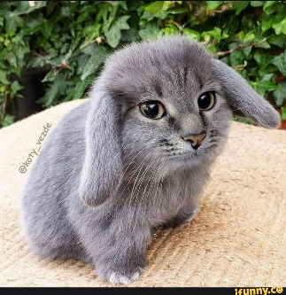

Asteptari legate de educatie:

Discipline: https://etti.utcluj.ro/planuri-de-invatamant.html
Disciplina | An | Link
Informatica Aplicata | 1 | https://etti.utcluj.ro/files/Acasa/Site/FiseDisciplina/EaRo/06.pdf
Programarea Calculatoarelor | 1 | https://etti.utcluj.ro/files/Acasa/Site/FiseDisciplina/TstRo/04a.pdf
Analiza matematica | 1 | https://etti.utcluj.ro/files/Acasa/Site/FiseDisciplina/TstRo/01a.pdf
Componente si circuite pasive | 1 | https://etti.utcluj.ro/files/Acasa/Site/FiseDisciplina/TstRo/05a.pdf
Fizica | 1 | https://etti.utcluj.ro/files/Acasa/Site/FiseDisciplina/TstRo/03.pdf

Hobby-uri:
- Sala
- Skateboard
- Masini
2**

1)
a)
Head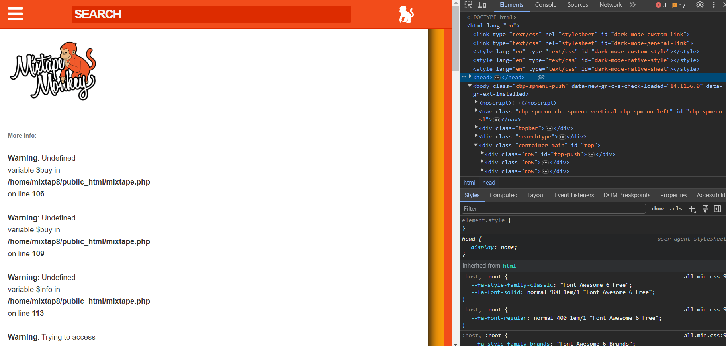

Body
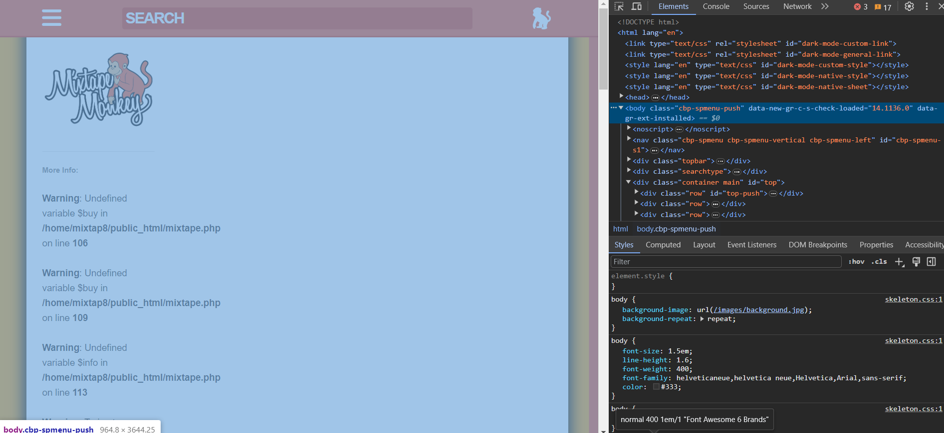

b)
Etichete folosite pentru:
i) imagine si titlu
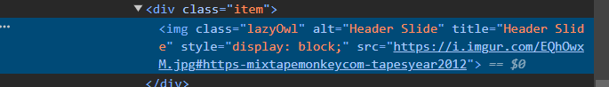


ii) liste si tabele
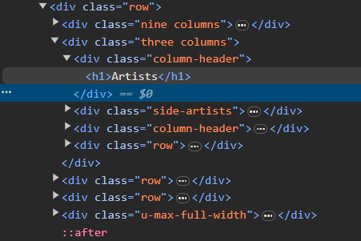
iii) functia de cautare
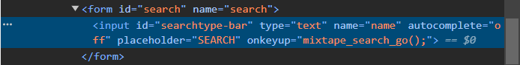

c)
Modificare continut
